CLASS TEST 1

Regular Expressions and Validation in JavaScript
1. Student Registration Validation: Write a JavaScript program to validate a student
registration form containing a full name, email address, 10-digit mobile number, date
of birth in DD-MM-YYYY format, and password. The password must contain at least
one uppercase letter, one lowercase letter, one digit, and one special character, with
a minimum length of eight characters.
A.Java Script:-
let name = "Asha Kumar";
let email = "asha@example.com";
let mobile = "9876543210";
let dob = "15-08-2005";
let password = "Hello@123";
if (name === "") {
console.log("Enter your name");
} else if (!email.includes("@")) {
console.log("Enter a valid email");
} else if (mobile.length !== 10) {
console.log("Mobile number must have 10 digits");
} else if (!/^\d{2}-\d{2}-\d{4}$/.test(dob)) {
console.log("Enter date as DD-MM-YYYY");
} else if (password.length < 8 ||
!/[A-Z]/.test(password) ||
!/[a-z]/.test(password) ||
!/[0-9]/.test(password) ||
!/[^A-Za-z0-9]/.test(password)) {
console.log("Password needs 8 characters, uppercase, lowercase, number, and symbol");
} else {
console.log("Registration is valid");
}

Output:-
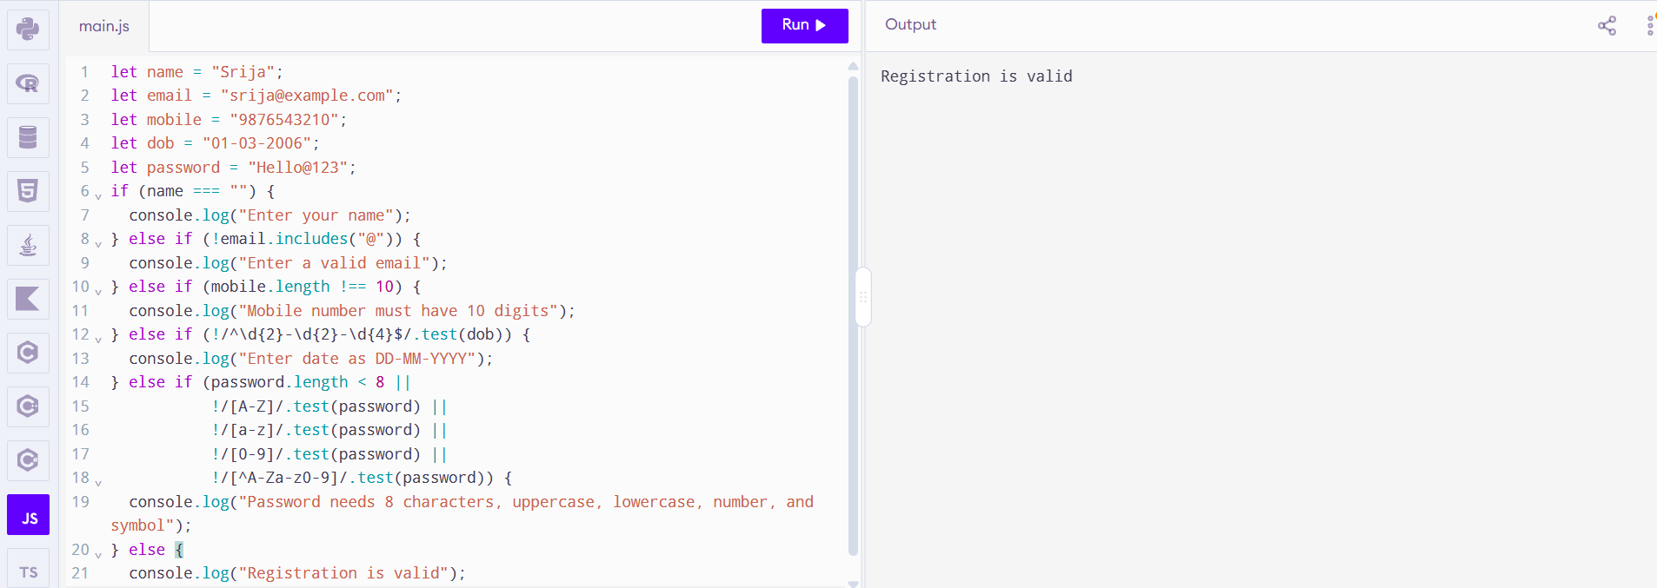

2. Password Strength Validation: Write a JavaScript program to validate a password
with the following rules: minimum 10 characters, at least two digits, one uppercase
letter, one lowercase letter, one special character, and no whitespace. Display an
appropriate error message for each failed condition.
A.Java Script:-
let password = "Hello@12345";
if (password.length < 10) console.log("Use at least 10 characters");
if ((password.match(/\d/g) || []).length < 2) console.log("Include at least 2 digits");
if (!/[A-Z]/.test(password)) console.log("Include an uppercase letter");
if (!/[a-z]/.test(password)) console.log("Include a lowercase letter");
if (!/[^A-Za-z0-9\s]/.test(password)) console.log("Include a special character");
if (/\s/.test(password)) console.log("Do not use spaces");
if (
password.length >= 10 &&
(password.match(/\d/g) || []).length >= 2 &&
/[A-Z]/.test(password) &&
/[a-z]/.test(password) &&
/[^A-Za-z0-9\s]/.test(password) &&
!/\s/.test(password)
) {
console.log("Password is valid");
}
Output:-
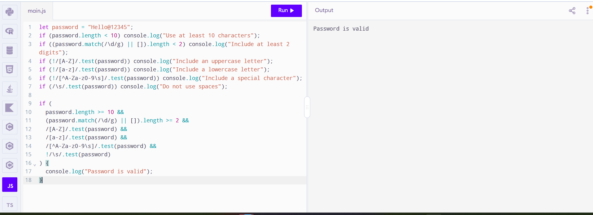

3. Email Address Validation: Write a JavaScript program to validate email addresses
according to these rules: the address must contain exactly one @, a non-empty
username, a domain name, and a valid-looking extension of at least two letters.
Reject spaces and consecutive dots.
A.Java Script:-
let email = "student@example.com";
let parts = email.split("@")
if (/\s/.test(email)) console.log("Email must not contain spaces");
else if (parts.length !== 2) console.log("Email must contain exactly one @");
else if (parts[0] === "") console.log("Username is required");
else if (!parts[1].includes(".")) console.log("Domain must include an extension");
else if (email.includes("..")) console.log("Email must not contain consecutive dots");
else if (!/[a-zA-Z]{2}$/.test(parts[1])) console.log("Extension must end with at least 2 letters");
else console.log("Email is valid");

Output:-
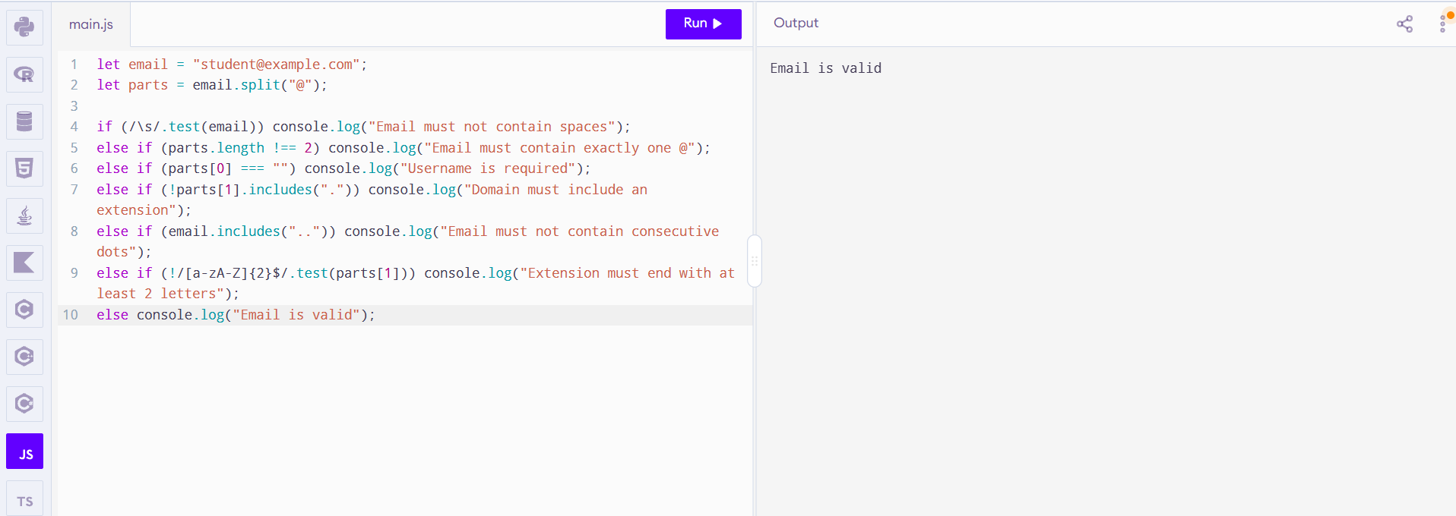

4. Username Validation: Write a JavaScript program to validate a username that
must start with a letter, contain only letters, digits, and underscores, have a length of
6–15 characters, and must not end with an underscore or contain consecutive
underscores.
A.Java Script:-
let username = "student_1";
if (username.length < 6 || username.length > 15)
console.log("Username must be 6–15 characters");
else if (!/^[A-Za-z]/.test(username))
console.log("Username must start with a letter");
else if (!/^[A-Za-z0-9_]+$/.test(username))
console.log("Use only letters, digits, and underscores");
else if (username.endsWith("_"))
console.log("Username must not end with an underscore");
else if (username.includes("__"))
console.log("No consecutive underscores allowed");
else
console.log("Username is valid");

Output:-
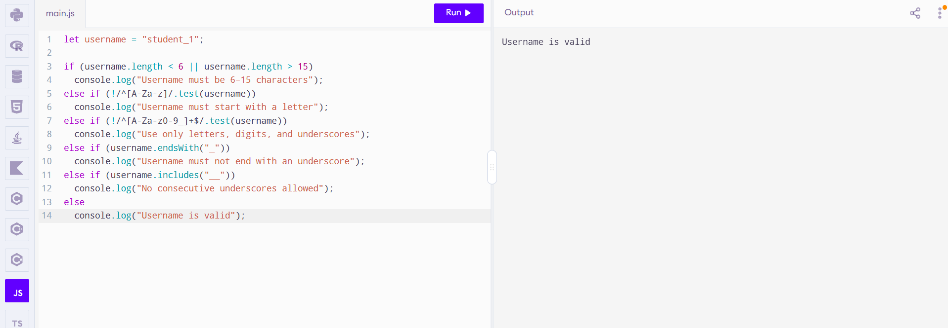

5. Extract and Analyse Data: Write a JavaScript program to extract all mobile
numbers, email addresses, and dates from a paragraph using regular expressions.
Display each category separately.
A.Java Script:-
let text = "Call 9876543210 or email sam@example.com. Date: 24-10-2026.";
let mobiles = text.match(/\b\d{10}\b/g) || [];
let emails = text.match(/\b[\w.-]+@[\w.-]+\.[A-Za-z]{2,}\b/g) || [];
let dates = text.match(/\b\d{2}-\d{2}-\d{4}\b/g) || [];
console.log("Mobile numbers:", mobiles);
console.log("Emails:", emails);
console.log("Dates:", dates);

Output:-
